boxy rather than hemispheric dome did not aggravate the seeing. Furthermore, the structural design, based on finite-element analysis, rescued the telescope from an awkward failure. There had been a laser system to maintain the accurate coalign-ment of the six telescopes. This system failed as a result of moths flying into the laser beams. The fallback procedure has been to co-align the telescopes on a nearby bright star, and then to lock the alignment and offset to the desired direction. Thanks to the rigid structural design, the co-alignment remained valid for about half an hour. Although that procedure would have been considered unacceptable in the initial specifications, it served quite successfully. On the other hand, it must still be a nuisance since the plan now is to replace the six telescopes with a single telescope having a greater collecting area. My major objection to the MMT concept is its lack of scalability. The problem is that the six cannot be increased to a much larger number.
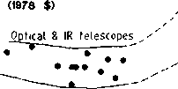
MIRROR COLLECTING AREA, m²
1 10 100 1000 10000
The latest size crown is held by the 10-meter Keck telescope. The segments of this telescope are figured as off-axis pieces of a parabola and have a hexagonal outline. Fabrication of the segments uses a technique called stress-mirror figuring, whereby the mirror blank is bent by weights and then is figured to a spherical surface. When the weights are released the figure springs back to that of the off-axis parabola. An initial problem was that the stressing could only be done for a spherical-outline blank, and when the blank became trimmed to a hexagonal outline, residual stresses slightly upset the figure. This problem may be fixed temporarily by warping harnesses that appropriately bend the mirrors while in the telescope. More recently, ion milling has been used to touch up the figure before mounting in the telescope. My main objection to all of this is that the resulting telescope is not inexpensive.
The co-alignment of the segments is based on capacitive edge sensors. To the best of my knowledge, their success is the first time that aperture segments have been maintained actively to astronomical tolerances without reference to the starlight itself.
Fixed Spherical Primary
Nevertheless, all of these endeavors have reaffirmed my longstanding conviction that the most economical way to construct a really large telescope is to use a fixed spherical reflector, just like the Arecibo radio telescope. In 1980, Aden Meinel presented a graph showing the cost per unit area as a function of diameter for various optical and radio telescopes. I have added several telescopes that he omitted to Figure 4. Note in particular that the Arecibo radio telescope is meritoriously so far removed from the herd of radio telescopes that it lies outside the original boundaries of the graph. At the same time, my own estimated cost for a fixed spherical primary optical telescope places it vectorialy displaced from the herd of optical telescopes, the same as the Arecibo case and for basically the same reasons. The spherical figure brings a multitude of virtues. For example, when segmented, all of the segments have the same figure, and, furthermore, that figure is far and

10°<-
o Fixed primary
10
olonnes
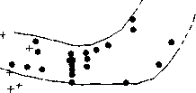
8
o
Radiotrelescopes
Solar concentrators
irecibo
12 5 10 20 50 100 200
MIRROR DIAMETER, m
figure 4. Relative costs of telescopes (adopted from A. Meinel).
away the easiest to make, test, and co-align. For those reasons, the mirror surface is far less expensive per unit area and the segmentation can be to thousands, rather than the small numbers for other schemes. Large numbers gain even further economies from mass production.
Cost estimation of individual mirrors can be done by expressing their cost as a polynomial function of diameter. There will be a constant fixed handling cost per mirror followed largely by the third order, the cost per unit weight. Dividing both sides by the square of the diameter gives the cost per unit area. This function has a rather deep minimum that occurs when cost attributable to weight is twice the cost per unit. If we empirically fit a curve to published prices of astronomical mirrors, we find that the minimum is indeed rather deep and occurs at about 0.2 to 0.25 meter diameter, a conspicuously small size. For that reason it is most economic to have many fairly small segments. On the other hand, that must be balanced with the necessity for more mounting and alignment fixtures, and so my preference would be about 0.75 meter size for the segments.
Another very important, if not the most important, feature of the spherical figure is that it has no axis; therefore the primary reflector may remain fixed, while steering is accomplished by moving only the much smaller and lighter auxiliary mirrors. A fixed primary would even do away with any need for active alignment, since almost all of the alignment problems arise from variations of gravitational loading that result from steering. However, there is a penalty in that more primary mirror surface is required because not all of the area is used at one time. This penalty
depends somewhat on the sky coverage desired, but for reasonable coverage the factor is about six. The enormous savings that accrue from the spherical figure would far more than make up for that penalty factor.
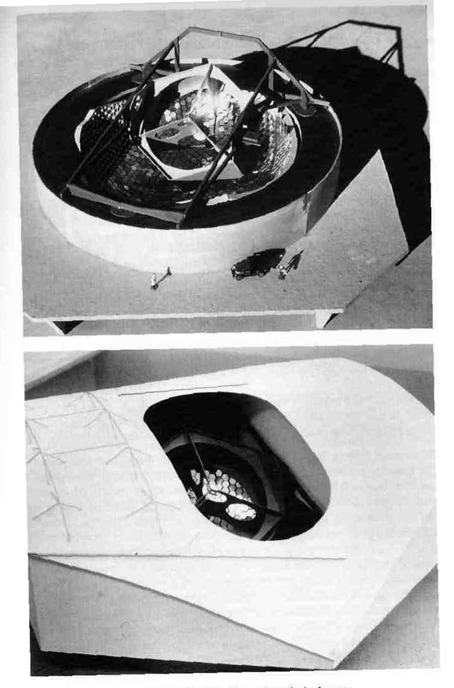
Since the concept for a fixed spherical primary never acquired the favor of any sponsorship, the best way for me ever to see how the overall engineering might fit together has been to construct a few models. Figure 5 pictures the most elaborate and corresponds to a 13-meter effective aperture, although the actual intention is for 15-meter effective aperture.
The mirror support structure is basically a geodesic frame built from very many identical aluminum castings, and the mirrors themselves are from diamond-machined aluminum blanks, probably with minor touch-up polishing. The main criteria for the alloy selection should be long-term stability after annealing and freedom from inclusions. It is quite inexpensive to diamond-machine the mirror surfaces since numerical control is unnecessary for generating spherical figures. It is also easy to polish spherical figures if the diamond-machined finish should need touching up. The casting shapes are sketched in Figure 6.
The geodesic form is a regular icosahedron inscribed in a sphere, where the faces of the icosahedron are filled with a triangular lattice and puffed out so that the vertices of that lattice also lie on the sphere. We are concerned only with about a 120° portion centered on one of the icosahedral faces. The three vertices of that face will be specially made to serve as the three- point support for the entire structure, and the rim also will have to be specially made quite rigidly to avoid warping. Although the triangular latticework necessarily involves an assortment of slightly different edges and angles, the identical castings shown in Figure 6 allow for the slight differences by having elongated holes for their lap jointing and by being thin enough to flex slightly near the hub of the casting. The mirror castings have a stress relief design so that their spherical figure will not get deformed from the simple three-screw adjustable attachment. The outlines of the mirror castings will be hexagonal, but trimmed to be slightly irregular so as to minimize the gaps between neighboring mirrors.
The optical configuration is shown in Figure 7. The geometric optical details will be discussed a little bit later. For the moment, suffice it to say that, except for the primary reflector, all of the components are mounted on a common frame. That alt-az steerable frame is supported in azimuth on three air pads. The frame must be held in accurate position with respect to the center of curvature of the fixed primary reflector. Here again the spherical figure of the primary is a blessing because if we have a point light source adjacent to a four-quadrant photo detector, and that light source is imaged at the center of the detector, then we know that the center of curvature of the reflector lies exactly halfway between the source and the detector. Simply to avoid obstructing the telescope beam with paraphernalia at the center of curvature, that center is folded downward with a small flat mirror. Now, if the folding flat is bent just a little to induce a small amount of astigmatism at 45° to the quadrants of the detector, then the difference signal of the diagonals of the quadrants also serves to measure focus in addition to the normal x-y sensing
figure 5. Model of Areciibo-style optical telescope.
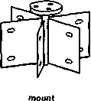
figure 6. Casting shapes.
of the quadrants. That copies the clever servo system ordinarily used for compact discs.
The shape of the dome lies somewhat in between the traditional hemispheric and the box of the MMT. Although the resemblance is more to a battleship gun-turret, the architectural form is fairly aesthetic. That is important since telescopes are meant to be inspiring. For this 13-meter version the dome diameter is about that of the Hale 5-meter telescope while being only about half as high. Much more importantly, the alt-az arrangement of the telescope allows an internal bracing structure within the dome so that it can be much lighter. (A fully hemispheric dome can be both light and strong, but when a slot is required the dome must become very much heavier to be adequately strong.) The internal structure includes walls so that there is a very comfortable, large observing room where the telescope focus conveniently arrives through one of the walls. There is even room for a visitor's gallery above the observing room, and an elevator provides access to those rooms from the ground.
The dome has a relatively short single-piece shutter which, as was mentioned earlier, is economical and easy to seal against inclement weather. The aperture spanned by the shutter is large, so that an exoskeleton is recommended for strength.
figure 7. Optical configuration.
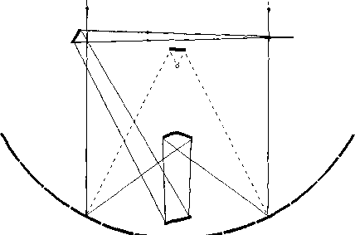
The dome itself is supported on air pads that share the same track as those that support the secondary mirror structure. That track is effectively the roof of an annular base building. There are two levels of rotating seal between the dome and the base building, and those two levels are separated by a corridor containing trolley-wire electrical power connections to the rotating dome. That corridor is restricted for maintenance, since open trolley wires present a hazard.
Any such large and radical telescope certainly should be preceded by a small-scale prototype. In this case, a 2-meter version would be about the smallest that might be really helpful. In fact, I did build a corresponding model prior to the model of the 13-meter version, and that prototype model strongly influenced many details of the adopted design.
Optical Design
The major objection to a spherical primary mirror comes from optical aberrations, mainly spherical and coma. These are especially serious with the very fast focal ratio (f/no 0.6) being considered here. The original incentive for designing this telescope was as a light collector for Fourier transform spectrometry; and in that case only one sharp pixel is required, so only the spherical aberration required correction. However, it shortly became clear that such a large telescope must be more versatile with a capability to produce good images that have many pixels. These demands led to my development of two geometric design procedures for the correction of arbitrary spherical aberration and coma. Zero spherical aberration occurs when the optical path length (OPL) for all rays is exactly the same. That is Fermat's Principle. Zero coma occurs when the rays satisfy the Abbe sine condition, whereby the sines of the ray angles through the focus are proportional to the initial ray heights at the entrance aperture. Thus all rays have the same image scale. Failure in that regard is called offence against the sine condition (OSC). When both of these aberrations have been corrected the optical system is said to be aplanatic, and the significance of such correction will be discussed subsequently. Treatises on optical design contain many equations, and good optical designers feel quite comfortable among those equations. On the other hand, there are those of us who feel quite uncomfortable amongst them, and so the procedures that I will describe are based more on geometric graphical concepts. It seems that this attitude productively complements the more traditional approach.
The first procedure is based on the simple optical behavior of ellipses that will be used to correct only the spherical aberration of a spherical mirror, or for that matter the spherical aberration of any ensemble of rays. By ray I mean not only a line in space, but also a direction along the line and a fiducial point on the line that specifies an instant of propagation time. A second point could be specified farther along on the ray. The points may be regarded as the tail and head of an arrow. Somewhere in between, however, the ray may be bent by reflection so that the second point will no longer lie on the line of the original ray. The idea of getting the light ray from the first point to the second suggests reflection at an elliptical
surface. The first and second points are the foci of an ellipse, and the time delay or path length of the ray arrow is equal to the major axis of that ellipse; knowing the positions of the foci and the major axis completely specifies the ellipse. The next question is where on the perimeter of the ellipse does the reflection take place? If the equation for the ellipse is expressed in polar coordinates about the initial focus, then the locus of the reflection is obtained directly from the direction of the initial ray. The polar equation for an ellipse should be well known as that for a Keplerian orbit to anyone having taken astronomy. It is

r = a (1 – e²)/(1 + e*cos $φ$)
where a is the semi-major axis and e is the eccentricity obtained from 2ae = f, where f is the distance between foci.. Figure 8 shows two ways to apply this concept to solve for a secondary reflector to correct the spherical aberration of a spherical primary mirror.
The idea is to bring an incident ray starting at H to an eventual focus at F via reflections at P and S such that the overall pathlength L is specified. The ellipse, shown dashed, osculates the secondary reflector at its reflection point S. The left-hand version chooses P and F as the foci of the osculating ellipse, and the distance HP must be subtracted from the overall path to get the major axis of that ellipse. The right-hand version chooses B and F as the foci, and the distances HP and PB must be subtracted from the overall path L to get the major axis. Both versions arrive at exactly the same secondary reflector, and the spherical aberration of the primary is completely nullified at F. The program for either version amounts to about a half-page of FORTRAN code, and that for version A is in Appendix 1. Required input information is radius of the primary, whose center of curvature serves as origin of the coordinate system, maximum entrance ray height, final focus position, and optical pathlength from the y-axis to that focus.
The procedure allows designing the secondary mirror for the configuration shown in Figure 7. Previous solutions to that problem by others have been more
figure 8. Geometries of osculating ellipses for calculating a secondary mirror that corrects spherical aberration. Geometry A forms the basis of program TELES in Appendix 1.
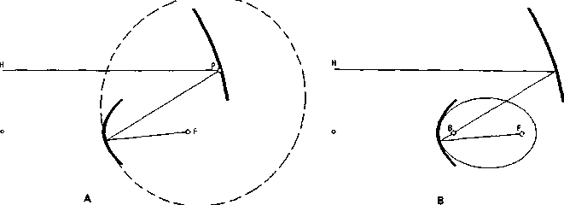
mathematical and less graphic. The final two folding mirrors of the configuration are flat, and so they do not contribute aberrations.
A curious design results when the final Gregorian focus (without any folding flats) is assigned to be coincident with or near the paraxial prime focus of the spherical primary. The secondary, as shown in Figure 9, looks like the inside of a wine glass. Notice that the rays converge on the focus from a solid angle of more than 3π steradians. If the configuration were used as a solar collector, the equilibrium temperature at the focus then would be hotter than that at the solar surface. That may seem odd, but remember that the solar surface sees a hemisphere of cool sky whereas the focus sees flux from almost all around. The configuration also would have made a superb searchlight, but the need for searchlights has practically vanished after World War II. The design also might be convenient for laser-driven inertial-confinement fusion since the focus gets impinged from so many directions.
The design of Figure 9 also can lead to an excellent microwave or millimeter wave antenna. Such a configuration already has been arrived at previously by von Hoerner (and perhaps a few other designers) using analytical techniques, and he recognized a special polarization problem. Were it not for polarization, the pattern at the focus of Figure 9 would provide an excellent match to that of a dipole oriented along the optic axis. The problem is that, when the reflectors unfurl the pattern, the polarization becomes radial over the aperture. Opposite sides of the aperture then cancel. Even though it is possible to design a wire antenna that would properly match the focal pattern, at the high radio frequencies involved wire antennae are too lossy. A better solution is to place a conical splash plate over the end of a waveguide feed as shown in Figure 10. Since the size of the splash plate is on the order of a wavelength, the details of its shape should take diffraction into account.
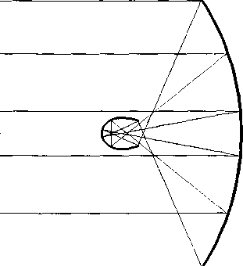
TELES 110. 60. 51. 177.
figure 9. Collector with spherical primary corrected for spherical aberration. Light comes to the focus over more than 3* steradians.
waveguide feed
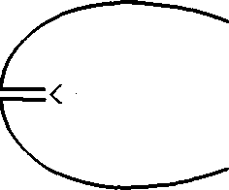
figure 10. Matching a waveguide to Figure 9 with a splash plate.
The real motive for such a configuration is quietness. The feed is practically in a Faraday cage and so sees almost no spurious illumination to contaminate the signal. That quietness should be very important for sensitive radio telescopes. For that reason, I would have thought this design preferable to the one actually selected for the upgrade of the Arecibo radio telescope, the upgrade being intended to receive more bandwidth than the original distributed line feeds. For radio telescopes in general, the configuration also offers other practical benefits such as ease of fabrication, alignment, and metrology. Sometimes, as with Arecibo, a fixed primary is tolerable; but when horizon-to-horizon coverage is required for aperture synthesis, a steerable primary is in order. Even with a steerable primary, though, this design still could be better than an orthodox parabolic reflector.
Moving the final focus even closer to the primary's center of curvature leads to the configuration of Figure 11. It is most unorthodox in that it presents a drastic
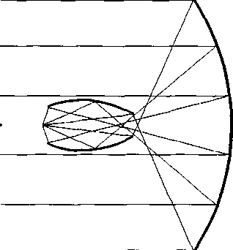
TELES 110. 60. 20. 207. figure 11. Strange Figure 11. Strange corrector for spherical aberration.
violation of Abbe's sine condition. We will concern ourselves much more about that condition a little later on. In this case, the sines of the emerging rays are not only not proportional to the sines of the incident rays (the entrance ray heights), but the outermost incident rays have the smallest angles onto the focus. The question is whether that is of any importance for a point source matching to a waveguide feed. I do have a vague recollection of such a configuration being published (probably in the 1950s) as a proposal for a radio telescope, but I am unable to track it down and nothing seems to have come of it. It is not at all clear whether the proposal was discarded for the sine problem, because it was too unorthodox, or for simple lack of interest.
While the telescope configuration of Figure 7 is sufficient for the original spec-trometric application, it fails to produce images at all. The reason for this failure is that the various zones of the aperture, even though they all focus to the same point, they do so with very different magnifications. Thus only the single-axial pixel stays sharp. Figure 12 shows effective focal length as a function of zone, and we can see that the inner zones end up with almost five times the magnification of the outer zones, so the discrepancy is very severe. The extreme severity of this coma results from the very fast focal ratio under consideration.
It turns out that there are a variety of ancillary optical systems that can correct the coma. A cleverly simple scheme that is based on a concept called hemisymmetry was suggested to me by Paul Robb. Imagine a 1:N scale replica of the telescope placed back to back with the telescope, such that their foci coincide, and insert a field lens such that the aspheric mirrors of each are conjugate. This arrangement is like the hemisymmetry described by Conrady, except that we have a focus rather than a pupil at the center of hemisymmetry. The arrangement constitutes an N power afocal telescope where the height of the exit ray is rigorously proportional to the height of the entrance ray to give uniformly the same magnification N for all zones. The afocal telescope then could be used in conjunction with a small good-quality camera to provide reasonable images.
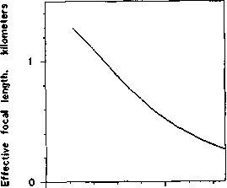
0 5
Zonal radius, meters
figure 12. Zonal variation of image scale for Figure 7. This is really severe coma.
Now it would be nice to dispense with the camera by incorporating its power into the telescope replica. Also, shifting the field lens toward the main telescope avoids the smallest asphere being uncomfortably small while keeping the overall length reasonable. The shifted field lens then also acts as a focal reducer to magnify the convergence angle of the focus and shift the focus toward the telescope. These modifications make the correcting optics appear as in Figure 13 and sufficiently perturb the hemisymmetry so that the larger mirror of the corrector must be slightly deformed to accomplish the coma correction. When both the coma and the spherical aberration are nullified, the system is said to be aplanatic.
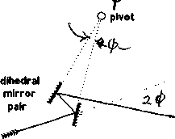
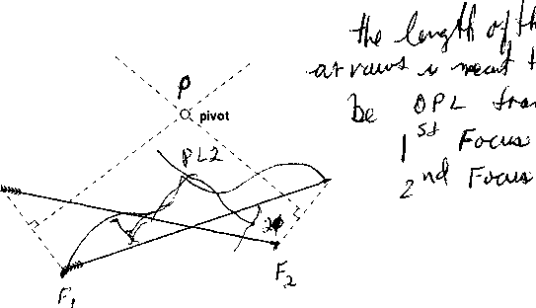
ray
The necessary deformation of the larger mirror in Figure 13 is estimated as follows. Reverse the propagation direction of Figure 13 so that it looks more like Figure 7 and adapt the calculation so that the light starts from the point as compared with the plane wavefront of Figure 7. The deformations from a spherical figure of the corrector's larger mirror, positions, and pathlengths all are judiciously adjusted until its magnification as a function of zone (analog of Figure 12) becomes a close match with Figure 12. Although this attempt can give substantial improvement, the match to Figure 12 persistently remains imperfect with disappointing performance.
Dihedral Remedy
The exasperation of trial-and-error groping for a match led me to a more basic approach that abandons any reliance on hemisymmetry and goes directly to the problem. The task is to take any given set of rays, such as those emerging from the focal point of the main telescope, and transform them into another set of rays having preassigned directions through a subsequent focal point while preserving optical pathlength (OPL) invariance.
The key to the reparation is based on the simple properties of a dihedral mirror. The double reflection from a dihedral mirror, as shown in Figure 14, ends up deviating a ray by twice the angle of the dihedral. Thus you can wobble the dihedral module without wobbling the direction of the output ray. Furthermore, if the dihedral pivots about its vertex, the output ray does not shift at all, not even with
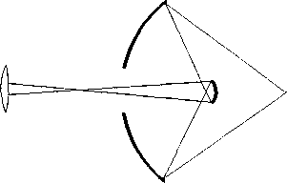
aspherics
field lens
figure 13. Coma correcting module for Figure 7.
figure 14. Reflection by a dihedral. Recognize that the result is invariant with respect to rotation of the module about the pivot.
respect to optical pathlength. Now suppose that we take an input ray segment of length PL and wish to rotate it to an output ray segment of the same pathlength as shown in Figure 15, where the segments are depicted as archery arrows having heads and tails. Just where would we place a hinge point such that the input arrow can be rotated to the position of the output arrow?
Figure 15 shows the geometric solution. The hinge or pivot point P is at the intersection of the perpendicular bisector between the tail positions and the perpendicular bisector between the head positions. Rotating either arrow about P can move it to the position of the other arrow. That rotation can be accomplished by establishing a dihedral mirror with vertex P and having the appropriate dihedral angle. For example, if one mirror intercepts a head or tail, the other mirror should lie on the adjacent perpendicular bisector. The dihedral then can take any rotational position about P without affecting the ray transformation. Each rotational position offers a pair of reflecting points, one on the input ray associated with one on the output ray.
Having accomplished the problem for one pair of input-output rays, the next step is to do it for a neighboring pair of input- output rays such that the reflecting facets describe smooth continuous surfaces. One way to do this is shown in Figure 16, where two neighboring rays are drawn. From a reflecting place Rl on one
figure 15. Finding the pivot for the dihedral reflective transfer of ray arrows.
Telescope Correction
19
18 1. Optical Telescopes

figure 16. Extrapolating the mirror surface from one ray intercept to the next.
p pivot 1
paverage P¹ / / ,.o pivot 2
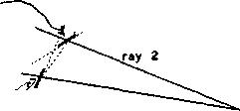
ray 1
ray, where its mirror surface must go through its pivot point PI, we want to get smoothly to a reflecting place R2 whose mirror surface will go through P2. A reasonable way to get there is to draw a line through R1 and the average of P1 with P2. The intersection of that line with the second ray gives R2.
Another way might be to draw two lines, one from Rl to PI and the other from Rl to P2. The average of their intersections with the second ray then would be R2. This second route is slightly lengthier computationally, but it may be easier if the procedure is expanded to three dimensions, because in that case the pivots are themselves lines and the average of two lines is awkward.
The programming for this is all very straightforward and simple, being based on the elementary analytic geometry of straight lines, perpendicular bisectors, and intersections. Program MPLAN for solving two-mirror aplanatic transfer systems is given in Appendix 1. It solves mirror shapes for transferring an ensemble of input rays to an ensemble of output rays. The program could be easily modified to accept a comatic input ensemble of rays for designing correctors such as those in Figure 13.
index of the operating medium. If its magnification were reduced to unity, the configuration would become two congruent prolate ellipsoids having colinear major axes and sharing a common focus.
The program also designs more conventional configurations such as Schwarzschild microscope objectives. These are rather like Cassegrain telescopes, except that the source is up close and the obscuration of the secondary is a real nuisance. That nuisance might be avoided by offsetting the secondary to give an off-axis system such as the one shown in Figure 18. While an off-axis version of the dihedral procedure program could design such systems, all we have to do is recognize that a spherically concave primary creates a rather good virtual image of the source, and the convex elliptical secondary transfers that virtual image to a magnified real image. The off-axis feature imparts some astigmatism, which could cured by a slight bending of either mirror.
Aside from possible application in soft X-ray lithography, another interesting prospect for Figure 18 would be dark-field illumination. You could simply shine a laser or other highly collimated light straight down through the hole in the primary for reflective illumination, or in the opposite direction, up toward the hole, for transmissive illumination. The interesting aspect is that now the illumination has low numerical aperture while the imaging has high numerical aperture commensurate with high resolution. This would be a beneficial reverse of conventional dark-field systems such as cardiod condensers.
Telescope Correction
Getting back to the task of aplanatic correction for spherical primary reflectors, the program MPLAN in Appendix 1 is easily modified so that the tails of the ray arrows emerge not from a point source but from the surface of the spherical

Microscope Objectives

Without modification, the program designs aplanatic all-reflecting microscope objectives. Typically, these have a concave primary and a smaller convex secondary like a Cassegrain telescope, and for the special circumstances of a Schwarzschild microscope objective their figures are essentially spherical. For different input parameters, however, the program generates extremely unusual objectives such as the one shown in Figure 17 whose numerical aperture almost equals the refractive

MPLAN 0.99 10. 6.12 0.7 figure 17. Fast aplanatic microscope objective.
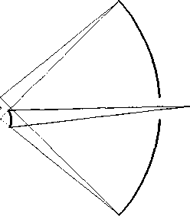
figure 18. Off-axis reflecting microscope objective.

